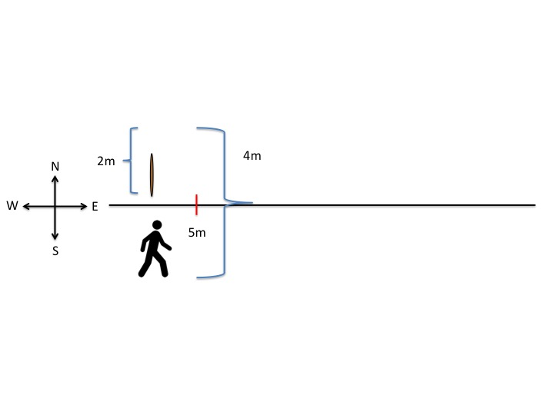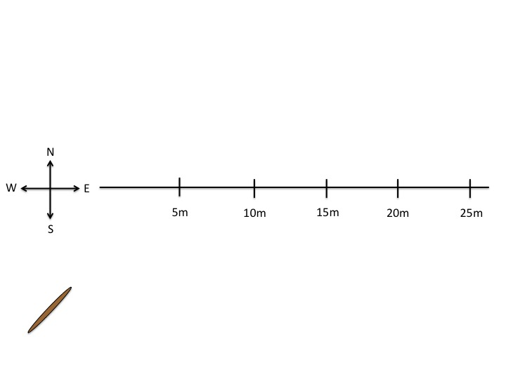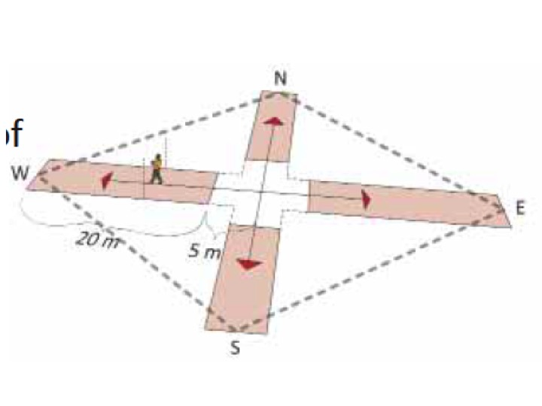

CUT TO: A similar image to the left will appear, showing how the entire observation process will occur.

FADE IN: A person will be shown walking the entire transect. At each mark, new trees will appear.

OPEN TO: The original cross will be displayed. One side will extend. There are larger trees on each side of the line. A person will walk the first 5m. A transparent block of color will appear on the sides of the lines, showing the 4m wide observation space.